EXPLANATORY NOTES TO THE FINANCIAL STATEMENTS

Part A – Explanatory Notes Pursuant to FRS 134 (formerly known as MASB 26)

A1. ACCOUNTING POLICIES AND COMPLIANCE WITH ACCOUNTING STANDARDS

The condensed interim financial statements for the 2nd quarter and 6 months ended 31 December 2004 have been prepared in accordance with Financial Reporting Standard (FRS) 134: Interim Financial Reporting (previously known as MASB 26) issued by the Malaysian Accounting Standards Board (“MASB”) and Chapter 9, part K of the Listing Requirements of the Bursa Malaysia Securities Berhad. The condensed financial statements should be read in conjunction with the audited financial statements of the Group and the Bank for the year ended 30 June 2004.

The accounting policies and methods of computation applied in the condensed financial statements are consistent with those adopted in the previous audited annual financial statements. The following accounting standards, issued by the Malaysian Accounting Standards Board (“MASB”) become effective during the current financial year:-
FRS 126 Accounting and Reporting by Retirement Benefit Plans (previously known as MASB 30)
FRS 120 Accounting for Government Grants and Disclosure of Government Assistance (previously known as MASB 31)
FRS 201 Properties Development Activities (previously know as MASB 32)

The adoption of these standards did not give rise to any adjustments to the opening balances of retained profits of prior years and the current period.

A2. AUDIT REPORT OF PRECEDING ANNUAL FINANCIAL STATEMENTS

The audit report on the financial statements for the financial year ended 30 June 2004 was not subject to any qualification.

A3. SEASONALITY AND CYCLICALITY OF OPERATIONS

The operations of the Group were not subject to material seasonal or cyclical effects.

A4. EXCEPTIONAL OR UNUSUAL ITEMS

There were no items of an exceptional or unusual nature that affects the assets, liabilities, equity, net income or cash flows of the Group.

A5. CHANGES IN ESTIMATES OF AMOUNTS REPORTED PREVIOUSLY

There were no changes to the estimates of amounts reported in prior financial years that may have a material effect in the current period.

A6. CHANGES IN DEBT AND EQUITY SECURITIES

The Bank’s issued and fully paid up share capital increased from RM3,600,171,921 to RM3,648,371,321 as result of the issuance of 48,199,400 new ordinary shares of RM1 each to eligible persons who have exercised their options under the Maybank Group Employee Share Option Scheme (ESOS).

Other than those above, there was no cancellation, repurchase, resale or repayment of debt and equity securities during the quarter.

A7. DIVIDENDS PAID

A final dividend of 25% less 28% tax for the financial year ended 30 June 2004, amounting to RM648,432,634 was paid on 27 October 2004.

(This page has been intentionally left blank. Please substitute this page with that from the file “Business Segment Reporting” as note A8i.)
A8ii. SEGMENT INFORMATION - LOANS, ADVANCES AND FINANCING ANALYSED BY ECONOMIC PURPOSES
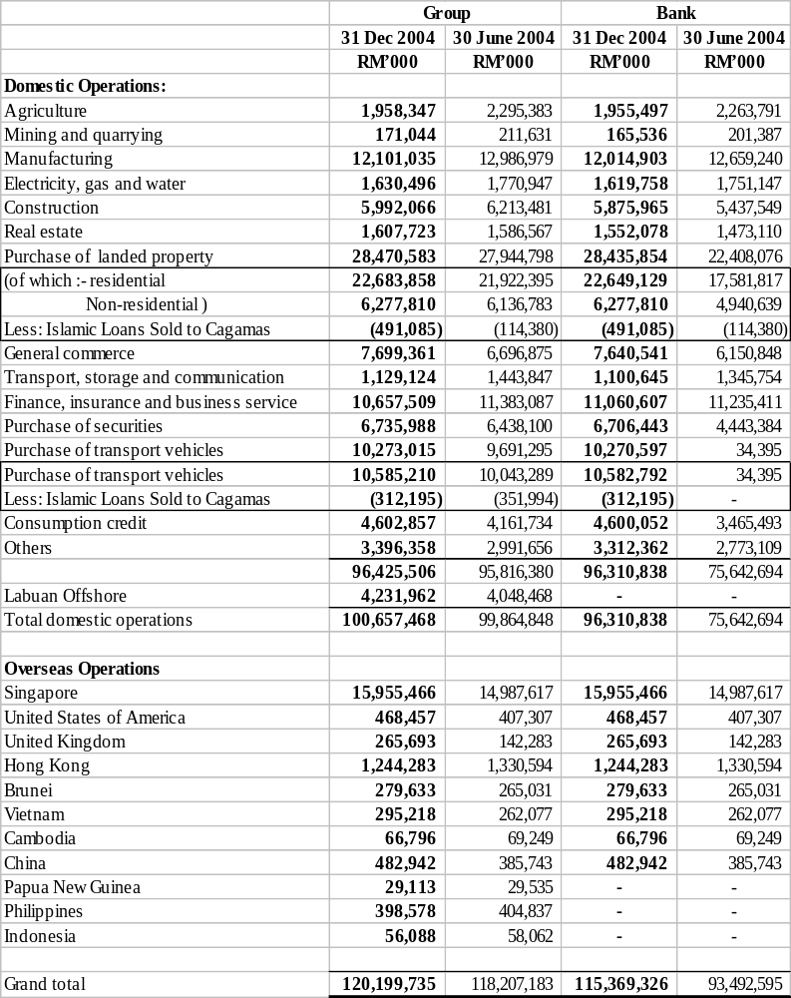
A8iii. Non –Performing Loans

 | Group |  | Bank
 | 31 Dec 2004 | 30 June 2004 | 31 Dec 2004 | 30 June 2004
 | RM’000 | RM’000 | RM’000 | RM’000
Gross balance at 1 July 2004/2003 | 12,274,256 | 13,037,159 | 9,458,681 | 9,799,074
Acquired upon merger with a subsidiary | - | - | 2,476,787 | -
Amount classified during the year | 3,432,725 | 6,962,093 | 2,624,817 | 5,481,905
Recovered/regularised | (2,743,205) | (5,646,100) | (2,248,893) | (4,217,085)
Amount written off | (1,647,346) | (1,907,297) | (1,517,138) | (1,526,796)
Converted to investment securities | (9,224) | (220,440) | (9,224) | (135,379)
Exchange difference & expenses
debited to customers’ account | 82,271 | 48,841 | 81,939 | 56,962
Gross balance at 31 Dec/30 June | 11,389,477 | 12,274,256 | 10,866,969 | 9,458,681
Less: Specific provisions | (3,062,405) | (3,624,130) | (2,909,191) | (2,688,326)
Interest/income-in-suspense | (1,596,303) | (1,891,555) | (1,567,315) | (1,396,440)
Net balance | 6,730,769 | 6,758,571 | 6,390,463 | 5,373,915
Gross loans, advances and financing | 120,199,735 | 118,207,183 | 115,369,326 | 93,492,595
Islamic loans sold to Cagamas | 803,280 | 466,374 | 803,280 | 114,380
 | 121,003,015 | 118,673,557 | 116,172,606 | 93,606,975
Less: Specific provisions | (3,062,405) | (3,624,130) | (2,909,191) | (2,688,326)
Interest/income-in-suspense | (1,596,303) | (1,891,555) | (1,567,315) | (1,396,440)
Net loans, advances and financing  (including loans sold to Cagamas) | 116,344,307 | 113,157,872 | 111,696,100 | 89,522,209
Total net non-performing loans (as % of total loans, advances and financing including Islamic Loans Sold to Cagamas, less Specific Provision and Interest-in-Suspense) | 5.79% | 5.97% | 5.72% | 6.00%

A8iv. Loan Loss Provision

Movements in the provision for bad and doubtful debts (and financing) and interest-in-suspense (income –in-suspense) accounts are as follows: -

 | Group |  | Maybank
 | 31 Dec 2004 | 30 June 2004 | 31 Dec 2004 | 30 June 2004
 | RM’000 | RM’000 | RM’000 | RM’000

General Provision
Balance at 1 July 2004/2003 | 3,621,007 | 3,474,440 | 2,689,417 | 2,590,235
Provision made during the year | 537,656 | 179,835 | 522,549 | 84,768
Amount written back | (549,049) | (47,147) | - | -
Transfer from specific provision | 28,651 | 11,428 | 27,685 | 11,801
Exchange differences | 7,584 | 2,451 | 7,641 | 2,613
Balance at 31 Dec/30 June | 3,645,849 | 3,621,007 | 3,247,292 | 2,689,417
As a percentage of total loans (including
Islamic loans sold to Cagamas, less
Specific provision and interest/income-in- suspense) | 3.13% | 3.20% | 2.91% | 3.00%
As a percentage of total risk-weighted
assets, excluding deferred tax assets | 2.94% | 2.92% | 2.61% | 2.81%
A8iv. Loan Loss Provision (cont’d)

 | Group |  | Maybank
 | 31 Dec 2004 | 30 June 2004 | 31 Dec 2004 | 30 June 2004
 | RM’000 | RM’000 | RM’000 | RM’000

Specific Provision
Balance at 1 July 2004/2003 | 3,624,130 | 4,541,801 | 2,688,326 | 3,405,370
Acquired upon merger with a subsidiary | - | - | 772,431 | -
Provision made during the year | 921,956 | 2,265,460 | 726,031 | 1,069,534
Amount written back in respect of
recoveries | (298,816) | (1,586,062) | (191,559) | (491,056)
Amount written off | (1,131,369) | (1,379,029) | (1,033,336) | (1,085,909)
Transfer to general provision | (28,651) | (11,428) | (27,685) | (11,801)
Transfer to provision for diminution in
Value of investments | (8,971) | (147,056) | (8,971) | (129,844)
Transfer to specific provision for
Restructured/rescheduled loans/financing | (35,841) | (63,893) | (35,841) | (76,227)
Exchange differences | 19,967 | 4,337 | 19,795 | 8,259
Balance at 31 Dec/30 June | 3,062,405 | 3,624,130 | 2,909,191 | 2,688,326
Interest-in-suspense/income in suspense
Balance at 1 July 2004/2003 | 1,891,555 | 1,892,670 | 1,396,440 | 1,433,206
Acquired upon merger with a subsidiary | - | - | 470,402 | -
Provision made during the year | 490,510 | 1,094,638 | 408,178 | 800,800
Amount written back in respect of
recoveries | (275,725) | (607,847) | (229,741) | (410,380)
Amount written off | (517,005) | (492,562) | (484,730) | (440,887)
Transfer to provision for diminution
in value of investments | (252) | (14,882) | (252) | (5,535)
Transfer (to)/from interest/income-in-
suspense for restructured/rescheduled
loans and financing | (2,776) | 14,851 | (2,776) | 14,851
Exchange differences | 9,996 | 4,687 | 9,794 | 4,385
Balance at 31 Dec/30 June | 1,596,303 | 1,891,555 | 1,567,315 | 1,396,440

A9. VALUATION OF PROPERTY, PLANT AND EQUIPMENT

Property, plant and equipment are stated at cost less accumulated depreciation and impairment losses.

A10. MATERIAL EVENT SUBSEQUENT TO THE END OF THE INTERIM PERIOD

There were no material events subsequent to the end of the interim period that require disclosure or adjustments to the financial statements.

A11. CHANGES IN COMPOSITION OF THE GROUP

Mayban Takaful Berhad

Mayban Takaful Berhad, a wholly owned subsidiary company of Mayban Fortis Holdings Berhad (MFHB), increased its issued and paid up capital from RM35.0 million to RM100.0 million through an issued of 65.0 million new ordinary shares of RM1 each to MFHB. MFHB is a 70% owned subsidiary of the Bank.

A12. CHANGES IN CONTINGENT LIABILITIES SINCE THE LAST ANNUAL BALANCE SHEET DATE

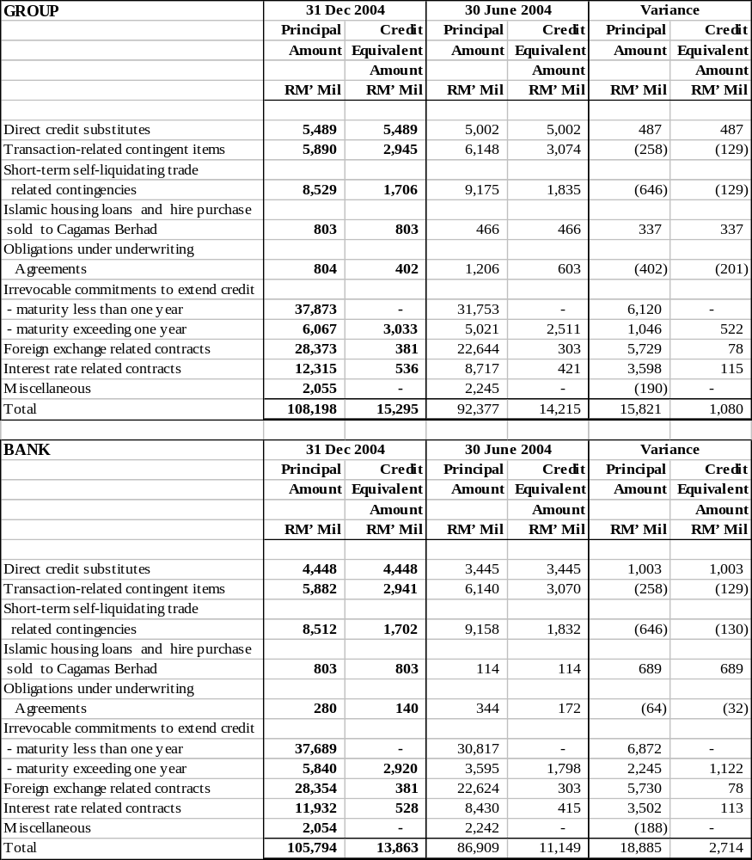

Part B – Explanatory Notes Pursuant to Appendix 9B of the Listing Requirements of Bursa Malaysia Securities Berhad

B1. REVIEW OF PERFORMANCE

For the 6 months ended 31 December 2004, the Group registered an increase of 14.1% or RM154.6 million in profit after tax and minority interest over that of the corresponding period. The better performance was supported by higher non-interest income arising from transactional banking activities and higher income from Islamic banking operations.

B2. COMPARISON WITH THE PRECEDING QUARTER’S RESULTS

The Group registered a profit after tax and minority interest of RM693.5 million for the quarter just ended compared to RM555.0 million for the preceding quarter, an increase of RM138.5 million or 25.0%. The increase was due to higher non-interest income earned and higher recovery of bad and doubtful debts for the current quarter as compared to the preceding quarter.

B3. PROSPECTS

The business environment in the second half is expected to be challenging in view of expected slower economic growth and increase competition. However, due to our inherent strength and capabilities, the Group is confident of maintaining its current performance during the second half of the financial year.

B4. VARIANCE FROM PROFIT FORECAST AND PROFIT GUARANTEE

The Group neither made any profit forecast nor issued any profit guarantee.

B5. TAXATION AND ZAKAT

 | Group
 | 31 Dec 2004
 | RM’000
Malaysian income tax | 518,786
Foreign income tax | 35,879
Less: Relief on foreign income tax | (23,753)
 | 530,912
Share of tax in associated companies | 375
Deferred tax | (24,848)
Tax expense | 506,439
Zakat | (3,980)
Tax expense & zakat | 502,459

The tax expense for the Group reflects an effective rate that approximates the statutory rate.

B6. PROFIT ON SALE OF UNQUOTED INVESTMENTS AND/OR PROPERTIES

The profits from the sale of unquoted investments of the Group amounted to RM113.1 million while profits from the sale of properties amounted to RM3.2 million.

B7. PURCHASE AND SALE OF QUOTED SECURITIES

Financial institutions are exempted from the disclosure requirements relating to securities that are quoted.

B8. STATUS OF CORPORATE PROPOSALS

Vesting of the Assets and Liabilities of Myfin Berhad (formerly known as Mayban Finance Berhad)

The assets and liabilities of Mayban Finance Berhad were vested over into Malayan Banking Berhad on 1 October 2004 via a Vesting Order dated 17 August 2004 issued by the High Court of Malaya. Consequently, Mayban Finance Berhad was renamed as Myfin Berhad with effect from 22 December 2004.

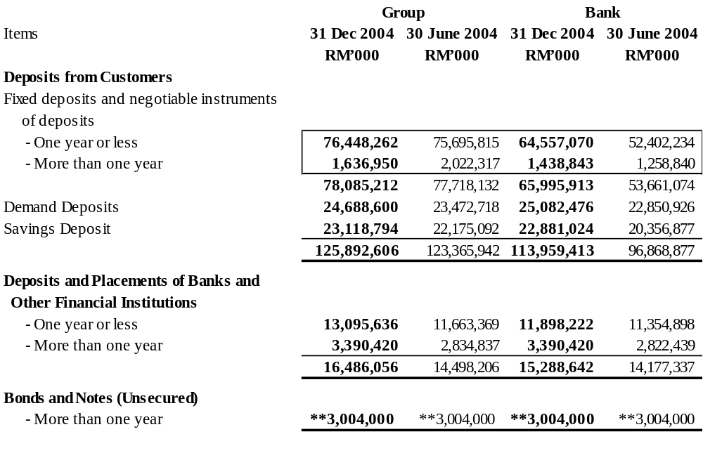B9. DEPOSITS AND PLACEMENTS OF FINANCIAL INSTITUTIONS AND DEBT SECURITIES

** Includes the Subordinated Note of USD630 million equivalent to RM2,394.0 million .

B10. OFF BALANCE SHEET FINANCIAL INSTRUMENTS BY VALUE OF CONTRACTS CLASSIFIED BY REMAINING PERIOD TO MATURITY/NEXT REPRICING DATE 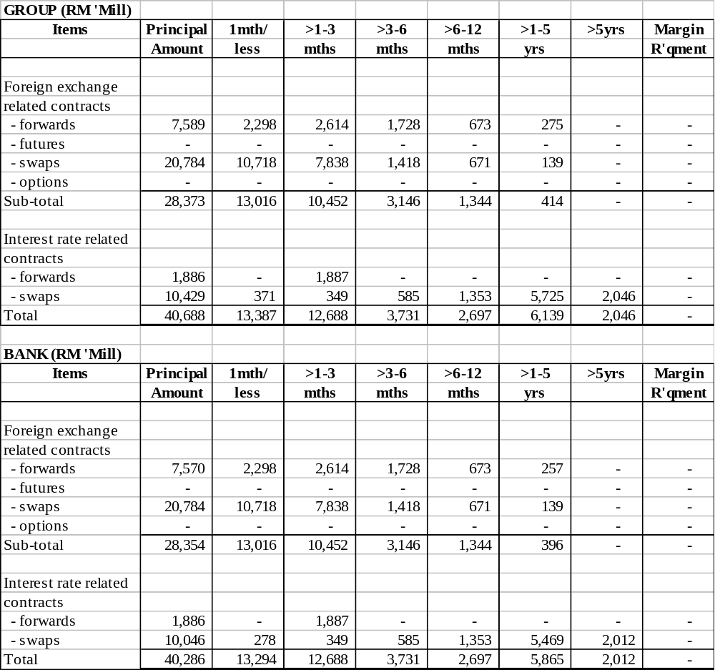(WHICHEVER EARLIER)

Market risk

Market risk is the potential change in value caused by movement in market rates or prices. The contractual amounts stated above provide only a measure of involvement in these types of transactions and do not represent the amount subject to market risk. Exposure to market risk transactions may be reduced through offsetting on and off-balance sheet positions.

Credit risk

Credit risk arises from the possibility that a counter–party may be unable to meet the terms of a contract in which the Group has a gain position. This amount will increase or decrease over the life of the contracts, maturity dates and rates or prices.

B10. OFF BALANCE SHEET FINANCIAL INSTRUMENTS BY VALUE OF CONTRACTS CLASSIFIED BY REMAINING PERIOD TO MATURITY/NEXT REPRICING DATE (WHICHEVER EARLIER) (CONT’D)

As at 31 December 2004, the amounts of market risk and credit risk are as follows:
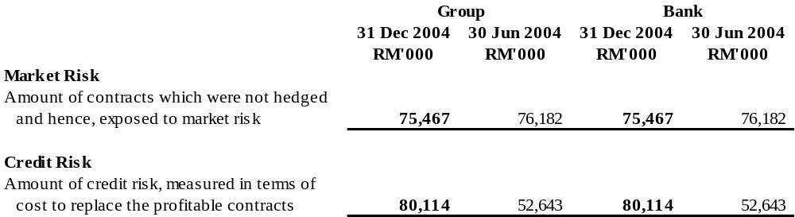

Related accounting policies

Foreign exchange contracts are revalued at the prevailing market rates at the balance sheet date and the resultant gains or losses are recognised in the income statement.

In the case of interest rate swaps, the differential interest receipts and payments arising therefrom, are accrued whilst the notional principal amounts are recorded as off balance sheet items.

B11. MATERIAL LITIGATION

At the date of this report, there was no pending material litigation.

B12. DIVIDENDS DECLARED

The Directors have declared interim dividends in respect of the financial year ending 30 June 2005 as follows:

- a dividend of 25.0 sen per share less 28% tax (Dec 2003: 10.0 sen per share less 28% tax);
- a special dividend of 10.0 sen per share less 28% tax (Dec 2003: 25.0 sen less 28% tax); and
- a special tax exempt dividend of 7.5 sen per share (Dec 2003: nil).

The total dividends declared for the current financial year to date amounted to 42.5 sen per share. The dividends will be paid on 31 March 2005 to shareholders registered in the books of Maybank on 18 March 2005.

The Share Transfer Books and the Register of Members of the Company will be closed from 19 March 2005 to 20 March 2005 (both dates inclusive). Duly completed transfers received by the Share Registration, Corporate Services of Maybank, 14th Floor Menara Maybank, 100 Jalan Tun Perak, 50050 Kuala Lumpur by 5.00 p.m. on 18 March 2005 will be registered before the entitlements to the dividend are determined.

A Depositor shall qualify for entitlement to the dividends only in respect of:-

- Shares deposited into the Depositors’ Securities accounts before 12.30p.m. on 16 March 2005 (in respect of shares which are exempted from mandatory deposit).

- Shares transferred to the Depositors’ Securities accounts in respect of ordinary transfers before 4.00 p.m. on 18 March 2005.

- Shares bought on the Bursa Malaysia Securities Berhad on a cum entitlement basis according to the Rules of Bursa Malaysia Securities Berhad.
B13. EARNINGS PER SHARE (“EPS”)

The basic EPS of the Group is calculated by dividing the net profit for the quarter and the six months by the weighted-average number of ordinary shares in issue during the quarter and the six months.

 | Group |  | Group
 | 2nd Quarter Ended |  | Cumulative 6 months Ended
 | 31 Dec 2004 | 31 Dec 2003 | 31 Dec 2004 | 31 Dec 2003
Net profit (RM’000) | 693,523 | 592,695 | 1,248,562 | 1,093,916
Weighted average number of
Ordinary shares in issue (’000) | 3,624,804 | 3,600,172 | 3,612,488 | 3,600,172
Basic earnings per share (sen) | 19.13 | 16.46 | 34.56 | 30.39

Diluted earnings per share (“Diluted EPS”)

The diluted EPS of the Group is calculated by dividing the net profit for the quarter and the six months by the weighted-average number of ordinary shares in issue, which has been adjusted for the number of shares that could have been issued under the Maybank Group Employee Share Option Scheme.

In the diluted EPS calculation, it was assumed that the share options were exercised into ordinary shares. A calculation is done to determine the number of shares that could have been issued at fair value (determined as the average price of the Bank’s shares during the quarter) based on the monetary value of the subscription rights attached to the outstanding share options. This calculation serves to determine the number of dilutive shares to be added to the weighted-average ordinary shares in issue for the purpose of computing the dilution. No adjustment was made to the net profit for the quarter.

 | Group |  | Group
 | 2nd Quarter Ended |  | Cumulative 6 months Ended
 | 31 Dec 2004 | 31 Dec 2003 | 31 Dec 2004 | 31 Dec 2003
Net profit (RM’000) | 693,523 | 592,695 | 1,248,562 | 1,093,916
Weighted average number of
ordinary shares in issue (’000) | 3,624,804 | 3,600,172 | 3,612,488 | 3,600,172
Assumed exercise of share
options (’000) | 40,549 | - | 33,779 | -
 | 3,665,353 | 3,600,172 | 3,646,267 | 3,600,172
Fully diluted earnings  per share (sen) | 18.92 | 16.46 | 34.24 | 30.39

By Order of the Board

Mahiram binti Husin
LS007885
Company Secretary
18 February 2005

